- Create positive and negative test cases in typescript code with playwright
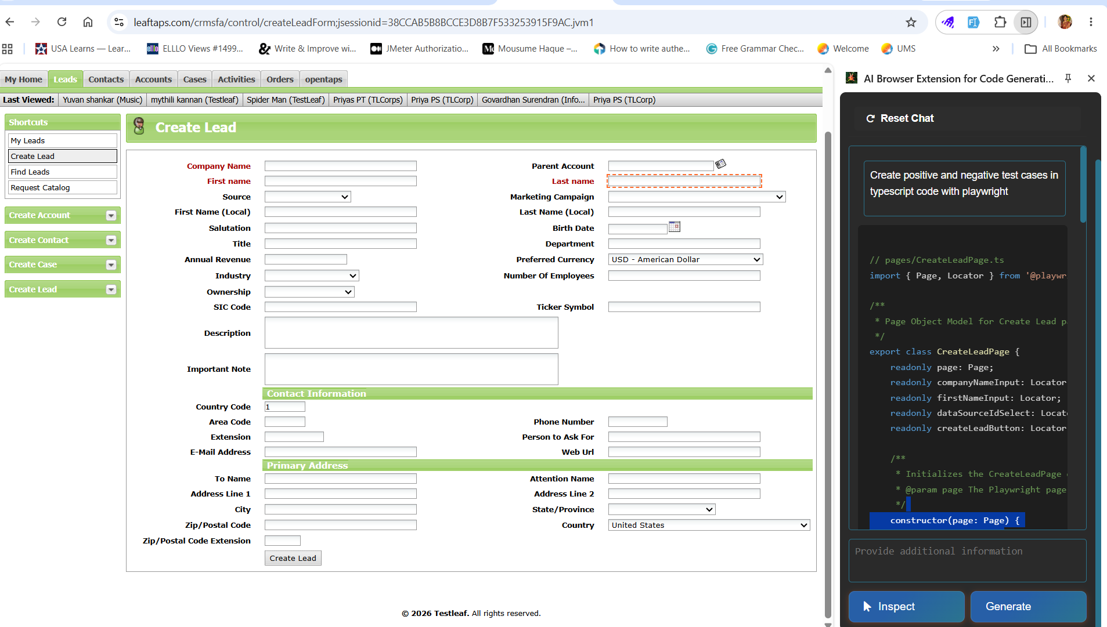
- Created the Playwright python code and also implemented the icon image changes.
